

Paper Due Date  
Feb 05, 2024

The ICT University

NDE HURICH DILAN

CCNA 1

Engr. Tanwi Nkiamboh

**FINAL EXAMINATION**

PRACTICAL EXAM: Routing Fundamentals

NAME: NDE HURICH DILAN

MATRICULE:ICTU20223351

EMAIL: nde.dilan@ictuniversity.edu.cm

TEL:+237694525931

**CCNA EXAM**

PRACTICAL EXAM: Routing Fundamentals

2) Configure hostnames on the routers according to the Lab Topology diagram.

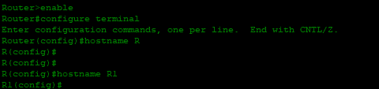

Using the hostname command on each router will do the job

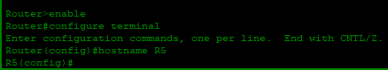

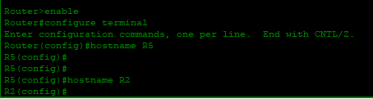

After that we need to enable the interfaces

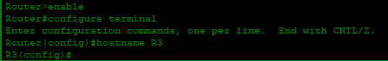

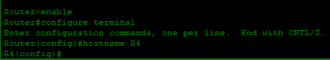

3) Configure IP addresses on R1 according to the Lab Topology diagram

The trick here is that the prefix length is /24 so the first 3 bytes are reserved hence the subnet mak is what we have there.

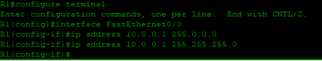







4) Verify routes have been automatically added for the connected and local networks (note that local routes only appear from IOS 15)

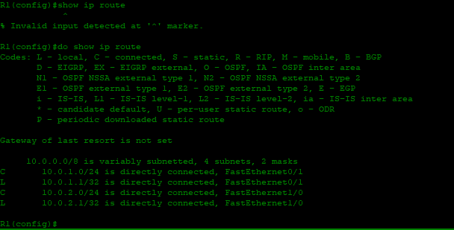

We can see that we have two local and 2 connected routes from here

5) Do you see routes for all networks that R1 is directly connected to? Why or why not?

Because the other routers are not yet configure

No

6) Should you be able to ping from PC1 to PC2? Verify this.

(Click on PC1 then 'Desktop' and 'Command Prompt' to access its command line interface.)

Yes it should be able to ping PC2 since the connection is established.

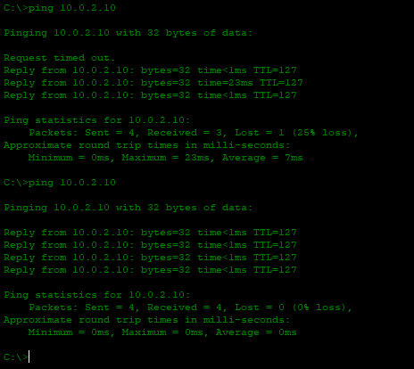

7) Verify the traffic path from PC1 to PC2. Use the tracert' command.

The **traceroute(tracert on Windows)**command is used to discover the routes that packets actually take when they travel to their destination.

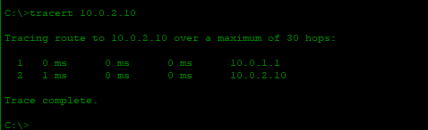

8) Should you be able to ping from PC1 to PC3? Verify this

No

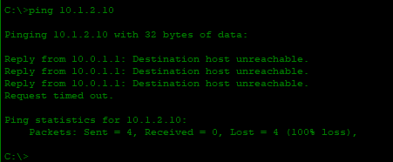

**Activity 2: Static Routes (13 Marks)**

9) Configure IP addresses on R2, R3 and R4 according to the Lab Topology diagram. Do not configure the Internet Fast Ethernet 1/1 interface on R4. Do not configure R5.

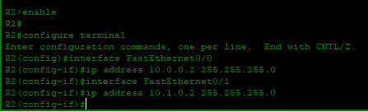

The trick here is that the prefix length is /24 so the first 3 bytes are reserved hence the subnet mak is what we have there.

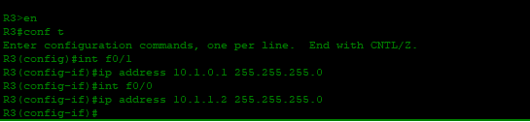

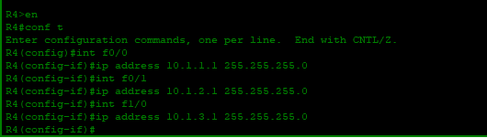

10) Verify PC3 can ping its default gateway at 10.1.2.1

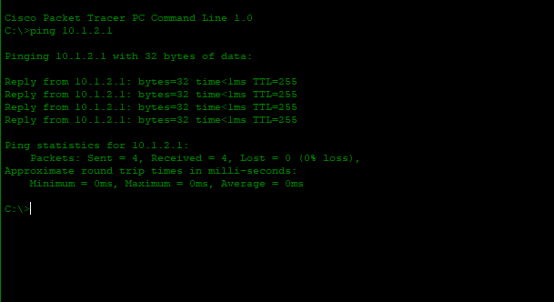

11)Configure static routes on R1, R2, R3 and R4 to allow connectivity between all their subnets. Use /24 prefixes for each network.

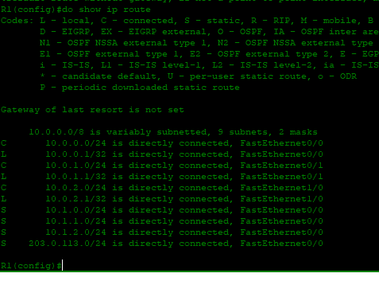

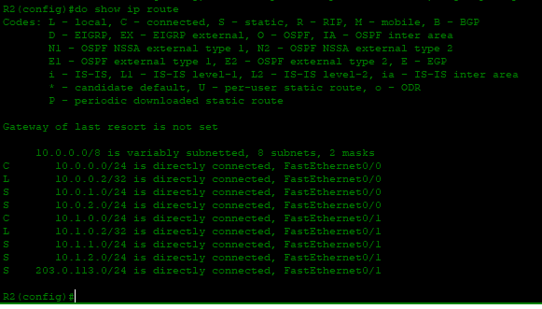

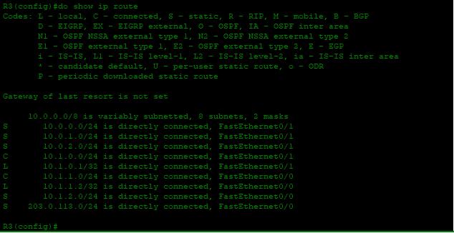

Same command everywhere :

Ip route add mask next-op

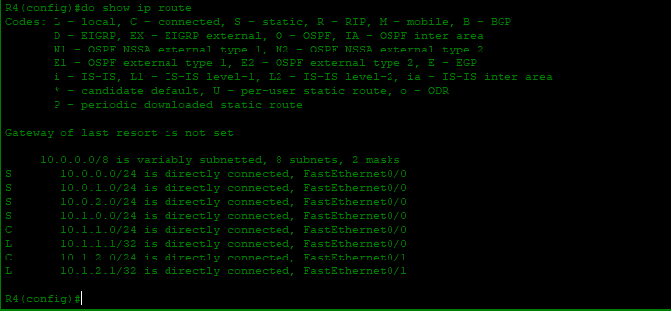

12)Verify connectivity between PC1, PC2 and PC3.

From PC1 to PC2

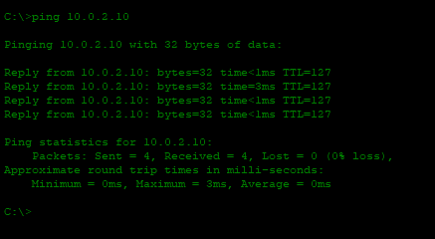

From PC1 to PC3 after 3 faillures 🥲

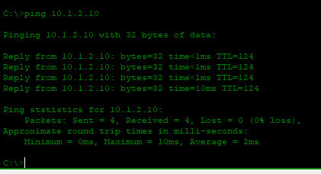

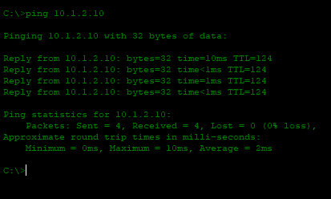

PC2 to PC1 Everything right the first time 🚩

From PC2 to PC3 after 1 faillure 🥲

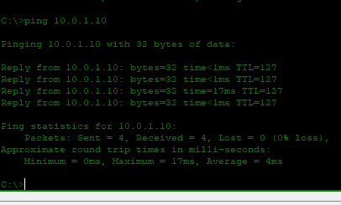

13) Verify the path traffic takes from PC1 to PC3.

PC3 to PC3 We can see the path taken and their corresponding IP addresses 🚩

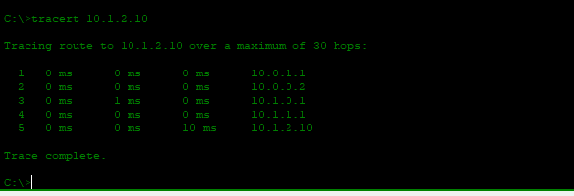

**Activity 3: Summary Routes (12 Marks)**

14) Remove all the static routes on R1

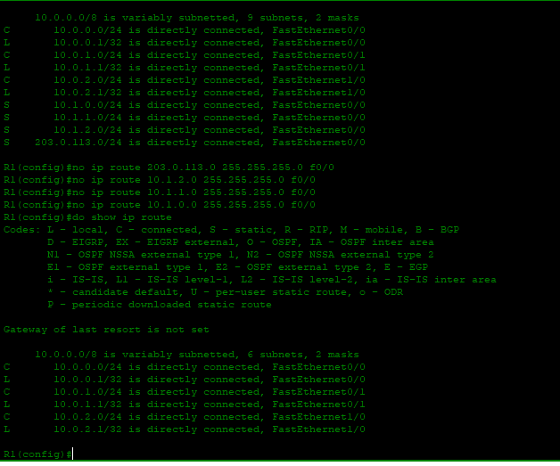

15) Verify that PC1 loses connectivity to PC3

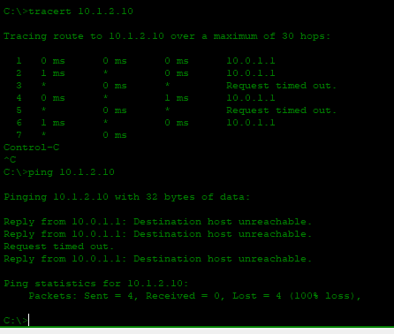

16) Restore connectivity to all subnets with a single command on R1.

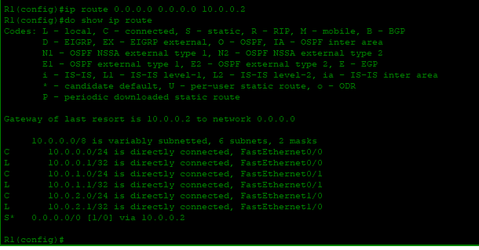

17) Verify the routing table on R1 does not contain /24 routes to remote subnets.

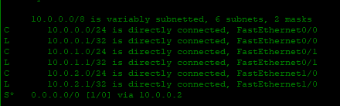

18) Ensure that connectivity is restored between PC1 and PC3. 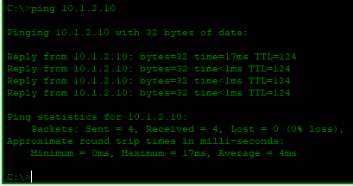

**Activity 4: Longest Prefix Match (15 Marks)**

19)Configure IP addresses on R5 according to the Lab Topology diagram

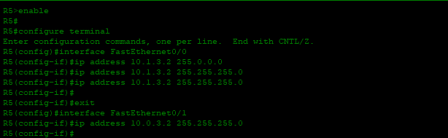

20) Do not add any additional routes. Does PC1 have reachability to the FastEthernet 0/0 interface on R5? If so, which path will the traffic take?

No, 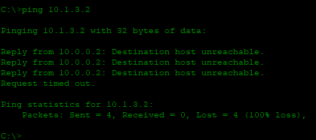

21) Ensure reachability over the shortest possible path from R5 to all directly connected networks on R1. Achieve this with a single command.

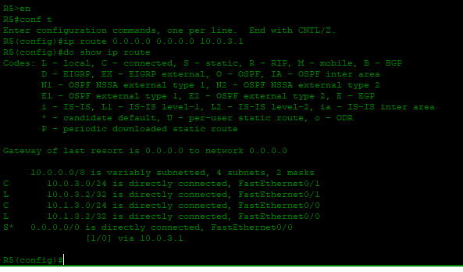

22) Verify the path traffic takes from PC1 to the FastEthernet 0/0 interface on R5.

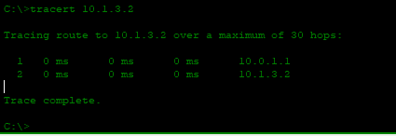

23) Verify the path the return traffic takes from R5 to PC1.

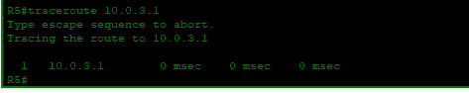

24) Ensure that traffic between PC1 and the FastEthernet 0/0 interface on R5 takes the most direct path in both directions.

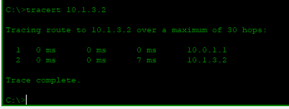

To ensure that ,we just need to check the routing table of R5 and see if the IP address of PC1 is there.

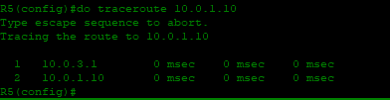

25) Verify that traffic between PC1 and the FastEthernet 0/0 interface on R5 takes the most direct path in both directions.



From PC1 to R5

From R5to PC1

**Activity 5: Default Route and Load Balancing (10 Marks)**

26) Configure an IP address on the Internet FastEthernet 1/1 interface on R4 according to the lab topology diagram.

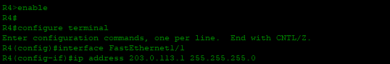

27) Ensure that all PCs have a route out to the internet through the Internet Service Provider connection on R4. (Note that the lab does not actually have Internet connectivity.)

To do this, we will configure the remaining routes on each router if necessary like that the PCs will be able to access the internet through the respectives routers.

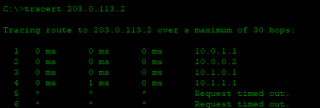

From the image we can see that everything is Okay till router 4 where the internet needs to reply with a message but can’t in our case

28) Traffic from PC1 and PC2 going to the internet should be load balanced over R2 and R5.